Grazioso Salvare Search & Rescue Dashboard
Charles Roaf
CS-340 Client/Server Development
Project Two
10/17/2026

Project Overview
For this project, I developed an interactive dashboard application for Grazioso Salvare, an organization that trains dogs for specialized search and rescue operations. The purpose of this dashboard is to allow users to access animal shelter records stored in MongoDB, identify dogs that meet specific rescue-training criteria, and visualize the resulting data through charts and geographic mapping.
The completed dashboard allows users to filter available dogs based on Water Rescue, Mountain/Wilderness Rescue, and Disaster/Tracking Rescue requirements. When a filter is selected, the dashboard automatically updates the data table, breed distribution chart, and geolocation map to display only the relevant results.
This project demonstrates my ability to develop a client/server application, integrate Python with MongoDB, and build an interactive user interface using the Dash framework.

Dashboard Functionality
To meet the project requirements, I created a dashboard that allows users to explore and analyze data from the Austin Animal Center database.
The dashboard includes the following features:
- Interactive rescue-type filtering options
- Dynamic data table displaying records from MongoDB
- Breed distribution pie chart
- Interactive geolocation map
- Grazioso Salvare branding and logo
- Unique identifier displaying my name
- Real-time updates using Dash callbacks
Users can select one of the following rescue categories:
- Water Rescue
- Mountain/Wilderness Rescue
- Disaster/Tracking Rescue
- Reset (returns all records)
When a filter is selected, all dashboard components update automatically to reflect the selected rescue category.

Dashboard Screenshots
Initial Dashboard (Reset)
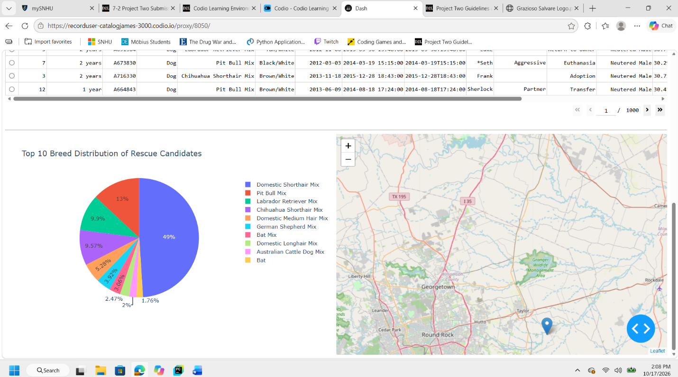

The initial dashboard displays all available records from the Austin Animal Center database. The data table, pie chart, and map provide an overall view of the available animals before any rescue filter has been applied.

Water Rescue Filter
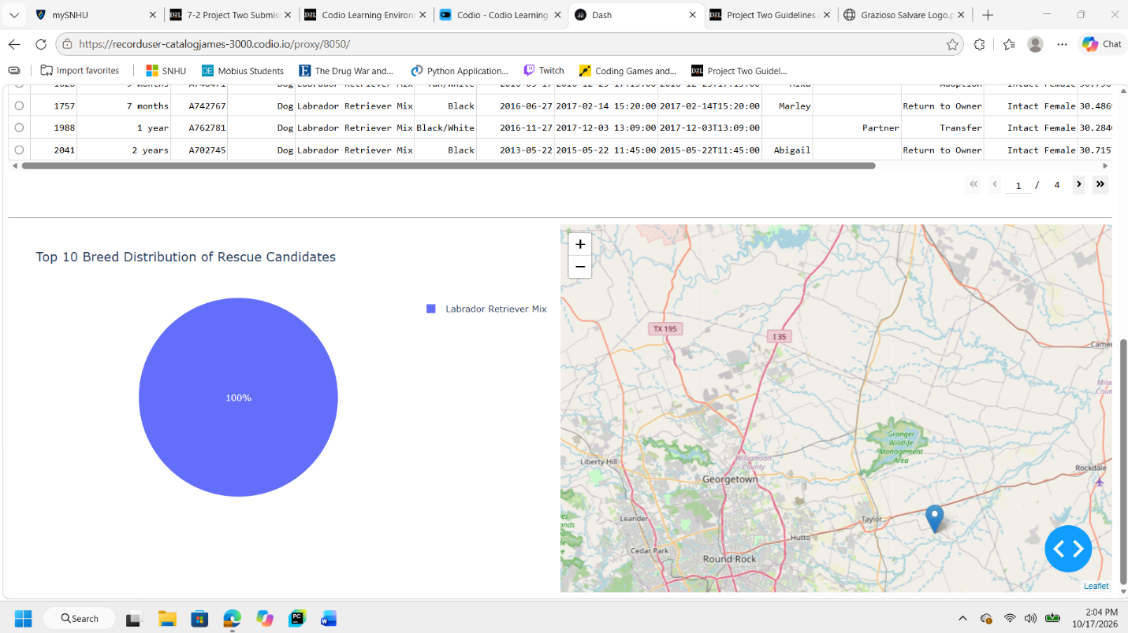
The Water Rescue filter displays dogs that meet Grazioso Salvare's criteria for water rescue training. The dashboard automatically updates the table, chart, and map to show only qualifying candidates.

Mountain/Wilderness Rescue Filter
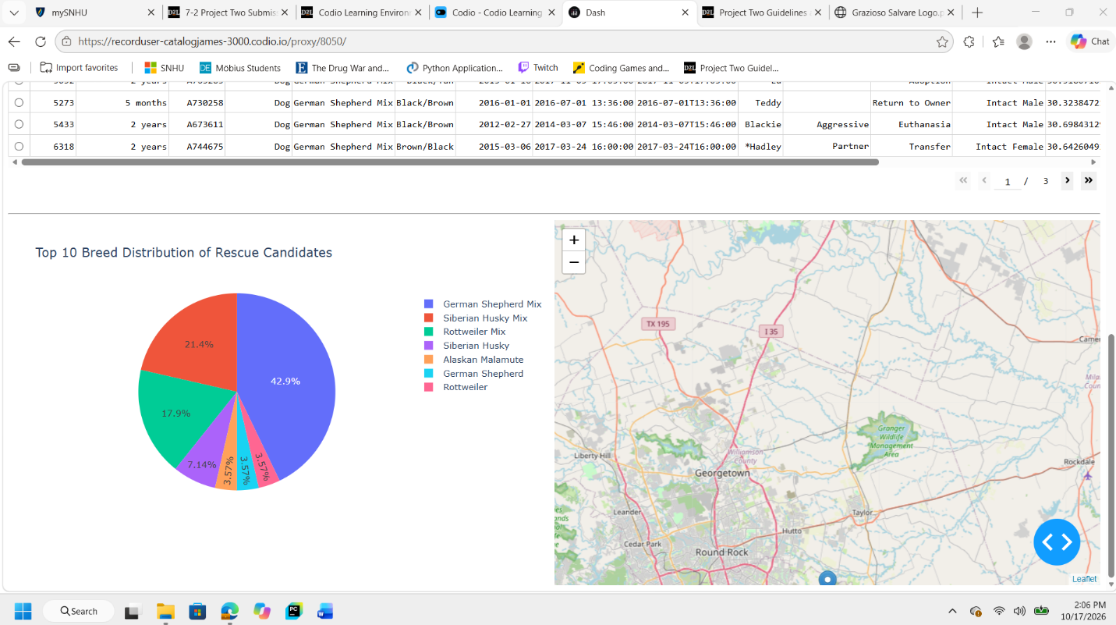
The Mountain/Wilderness Rescue filter displays dogs that meet the age, breed, and sex requirements associated with mountain and wilderness rescue operations.

Disaster/Tracking Rescue Filter
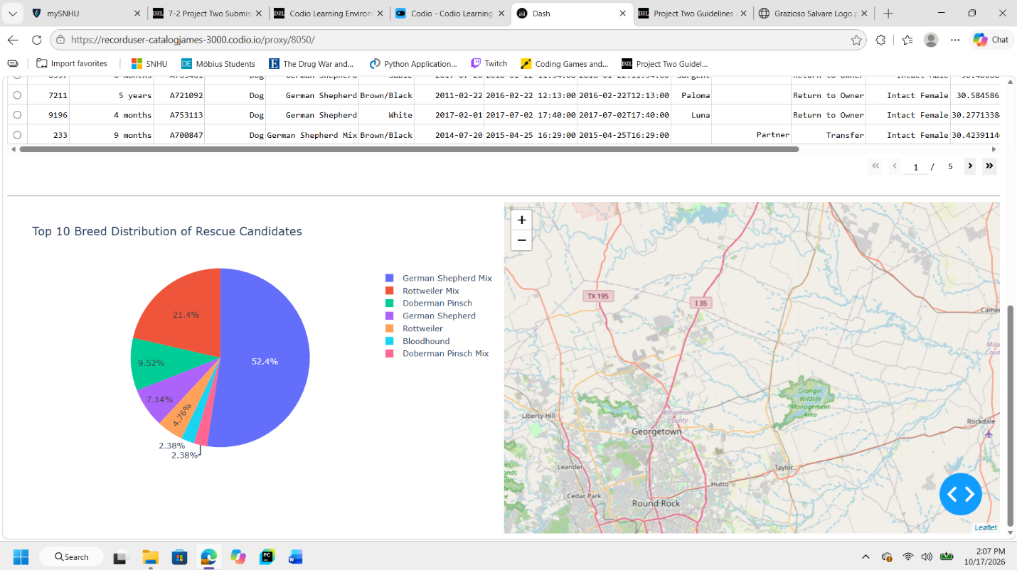
The Disaster/Tracking Rescue filter displays dogs that meet the requirements for disaster response and human tracking work. The dashboard updates instantly to display the filtered results.

Tools and Technologies Used
Python
I used Python as the primary programming language for both the CRUD module and the dashboard application. Python provided the flexibility needed to connect to MongoDB, process data, and develop the user interface.
Why I Chose Python
- Easy integration with MongoDB
- Strong support for data analysis
- Extensive library support
- Efficient development and testing

MongoDB
I used MongoDB as the database management system and as the Model component of the MVC architecture.
Why I Chose MongoDB
MongoDB is a document-based NoSQL database that provides flexible data storage and efficient querying capabilities. The Austin Animal Center dataset contains a large number of records and attributes, making MongoDB a suitable choice for storing and retrieving the data.
MongoDB also integrates seamlessly with Python through the PyMongo library, which allowed me to create a custom CRUD module that supports database operations and dashboard filtering.
MongoDB as the Model
Within the MVC architecture, MongoDB serves as the Model because it stores all application data and supplies records to the dashboard when queries are executed.

PyMongo
I used PyMongo to establish communication between Python and MongoDB.
PyMongo allowed me to develop a CRUD Python module capable of performing the following operations:
- Create
- Read
- Update
- Delete
The dashboard uses the Read operation to retrieve filtered records from MongoDB based on user selections.

Dash Framework
I used the Dash framework to create the dashboard interface and implement the application's interactive functionality.
Why I Chose Dash
Dash allows web applications to be developed entirely in Python while supporting interactive user interface components and real-time updates.
Dash provided:
- Radio button filters
- Interactive DataTable functionality
- Callback functions
- Dynamic page updates
- Web-based deployment
Dash as the View and Controller
Within the MVC architecture, Dash serves as both the View and Controller.
The dashboard interface acts as the View, while Dash callback functions act as the Controller by responding to user input and updating dashboard components.

Plotly
I used Plotly to create the breed distribution chart displayed within the dashboard.
Why I Chose Plotly
- Professional visualizations
- Easy integration with Dash
- Interactive charts
- Dynamic updates through callbacks
Plotly allowed me to present breed distribution data in an easy-to-read graphical format.

Dash Leaflet
I used Dash Leaflet to create the interactive map that displays animal locations.
Why I Chose Dash Leaflet
- Geographic visualization capabilities
- Interactive mapping functionality
- Integration with latitude and longitude coordinates stored in MongoDB
The geolocation map allows users to visualize the locations associated with selected records.

MVC Architecture
I developed this application using the Model-View-Controller (MVC) design pattern.
Model
The Model consists of MongoDB and the Austin Animal Center database collection that stores all animal records.
View
The View consists of the dashboard interface, including:
- Data table
- Rescue filters
- Breed distribution chart
- Geolocation map
- Grazioso Salvare logo
- Dashboard titles and identifiers
Controller
The Controller consists of:
- Dash callback functions
- CRUD Python module
- User interaction logic
The controller processes user selections and updates all dashboard components accordingly.

Project Development Process
I completed this project using the following development process:
- Imported the Austin Animal Center dataset into MongoDB.
- Developed a CRUD Python module using PyMongo.
- Tested all CRUD functionality and database connectivity.
- Created the dashboard structure using Dash.
- Added Grazioso Salvare branding and dashboard identification.
- Implemented interactive rescue-type filters.
- Developed MongoDB queries for each rescue category.
- Connected the dashboard to MongoDB through the CRUD module.
- Built a dynamic DataTable to display retrieved data.
- Created a breed distribution pie chart using Plotly.
- Created an interactive geolocation map using Dash Leaflet.
- Tested all dashboard functionality.
- Captured screenshots demonstrating successful operation of each filter.

Challenges Encountered
Challenge 1: Creating Rescue-Specific Queries
One challenge I encountered was creating MongoDB queries that accurately identified dogs meeting the requirements for each rescue category. Each query needed to evaluate breed, age, and sex requirements simultaneously.
Solution
I used MongoDB operators including:
- $and
- $in
- $gte
- $lte
These operators allowed me to build precise filters that returned only the records required for each rescue category.

Challenge 2: Synchronizing Dashboard Components
Another challenge involved ensuring that all dashboard components updated simultaneously whenever a rescue filter was selected.
Solution
I implemented Dash callback functions that connected the radio button filters to the DataTable, chart, and map. This ensured that all components displayed consistent information whenever the selected rescue category changed.

Challenge 3: Improving Data Visualization
Initially, the breed distribution chart displayed every breed contained within the selected dataset, making the visualization difficult to read.
Solution
I modified the chart to display only the top ten breeds within the filtered data. This produced a cleaner, more professional visualization that improved readability and overall dashboard appearance.

Instructions for Reproducing the Project
Software Requirements
To reproduce this project, the following software and libraries are required:
- Python 3.x
- MongoDB
- Jupyter Notebook
- Dash
- Plotly
- Dash Leaflet
- Pandas
- PyMongo
Installation and Setup
- Start the MongoDB service.
- Import the Austin Animal Center dataset into the aac database and animals collection.
- Place CRUD_Python_Module.py and ProjectTwoDashboard.ipynb in the same project directory.
- Install all required Python libraries.
- Open the notebook in Jupyter Notebook or Jupyter Lab.
- Run all notebook cells.
- Launch the dashboard application.
- Open the generated dashboard URL in a web browser.
- Use the rescue-type filters to explore and analyze rescue dog candidates.

Conclusion
In this project, I successfully developed an interactive dashboard application for Grazioso Salvare using MongoDB, Python, Dash, Plotly, and Dash Leaflet. The completed application allows users to identify potential search and rescue dog candidates through dynamic filtering, data visualization, and geographic mapping.
The dashboard successfully meets all project requirements by providing:
- Interactive rescue-type filtering options
- Dynamic updates to all dashboard components
- MongoDB database integration through a custom CRUD module
- Breed distribution visualization
- Geographic location visualization
- A user-friendly interface for analyzing animal shelter records
Through this project, I demonstrated my ability to apply database systems concepts, develop client/server applications, integrate Python with MongoDB, and implement interactive dashboards that transform raw data into meaningful information. This project strengthened my understanding of database connectivity, web application development, data visualization, and the Model-View-Controller design pattern.

Resources
The following resources and software were used during the development of this project:
- MongoDB
- PyMongo
- Dash Framework
- Plotly
- Dash Leaflet
- Jupyter Notebook
- Austin Animal Center Outcomes Dataset
- SNHU CS-340 Dashboard Specifications Document
- Grazioso Salvare Logo provided with project materials

